**Design Document – Lab 1**

Jared Brown

**Drone FSM**

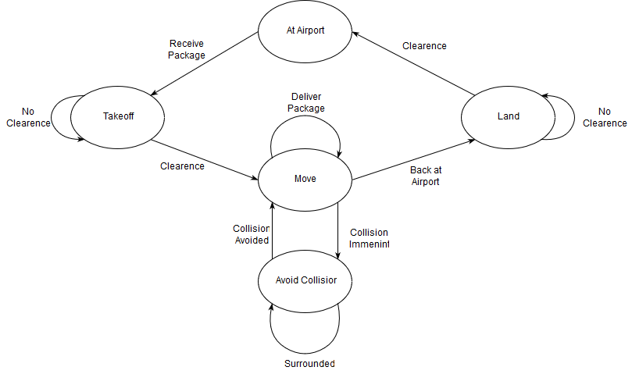

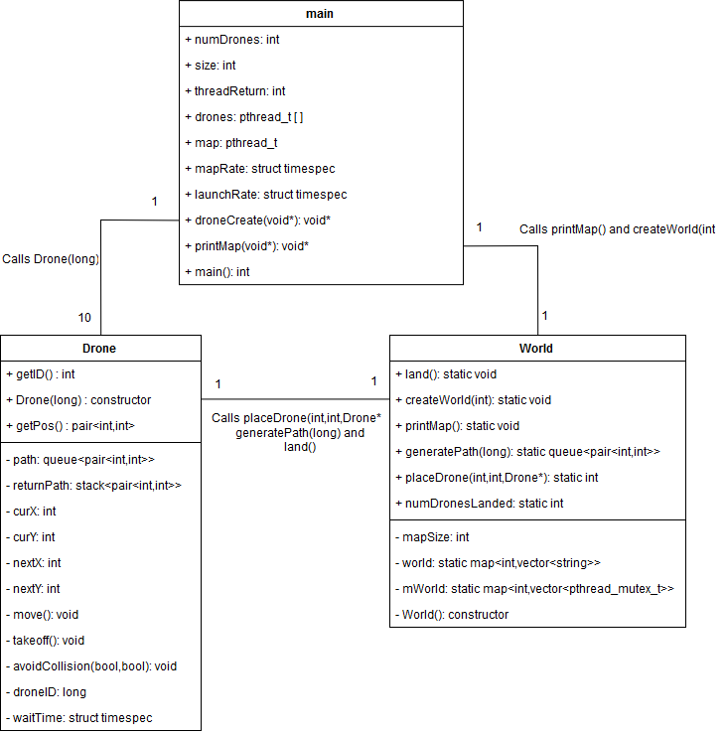**Class Diagram**